Name: Yadnesh Patil
PRN:123B1D034
Assignment no:08

- Create Database PCCOE
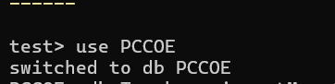
- Create following Collections Teachers(Tname,dno,dname,experience,salary,date_of_joining ) Students(Sname,roll_no,class)
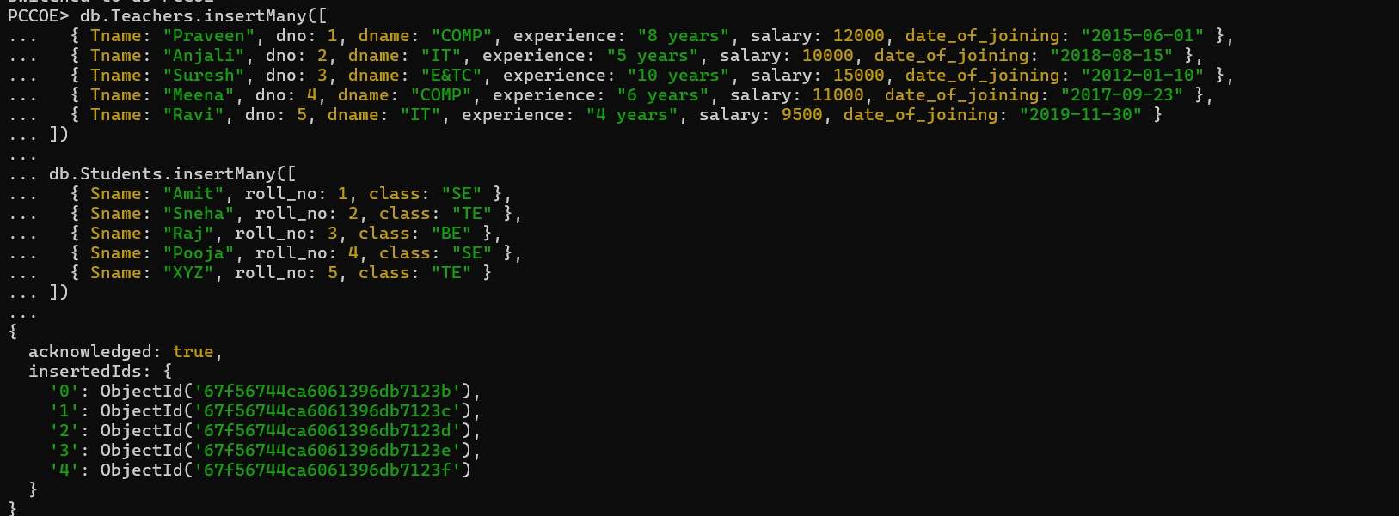
- Find the information about all teachers
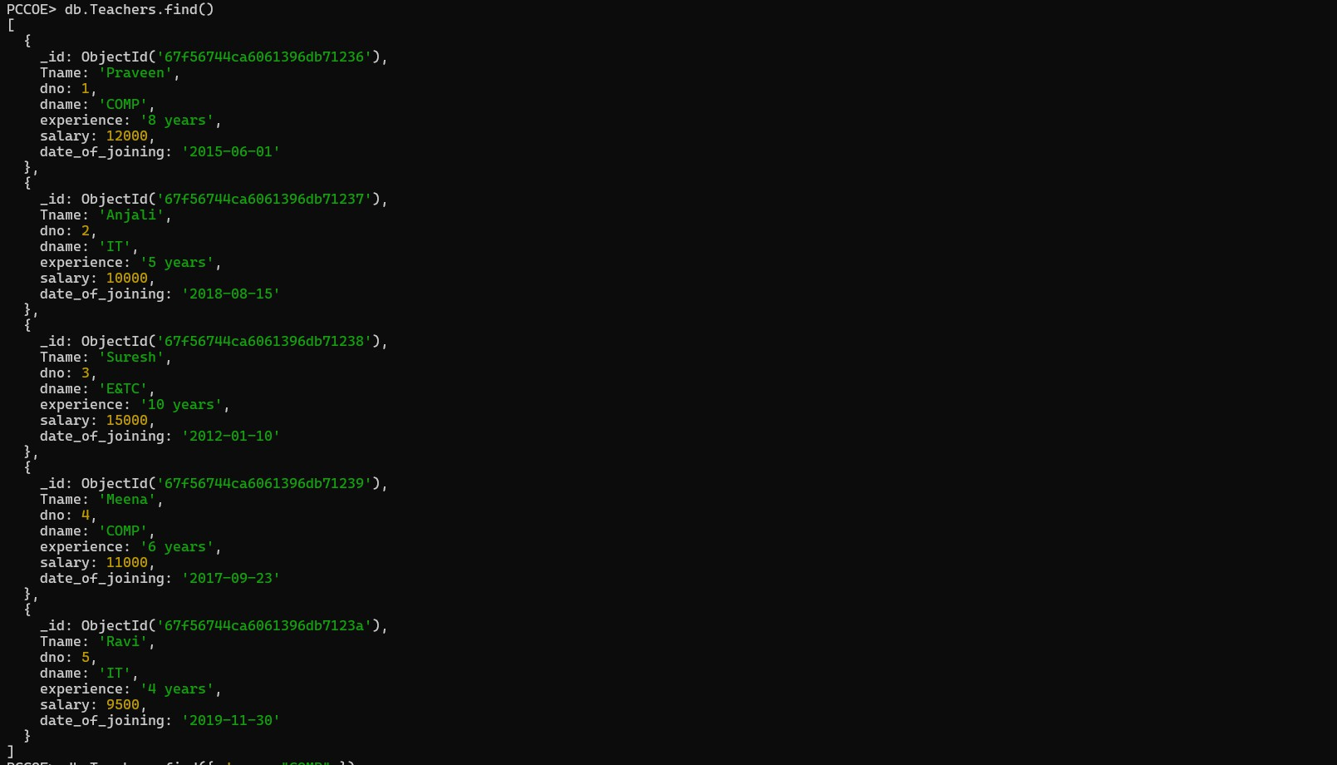

- Find the information about all teachers of computer department
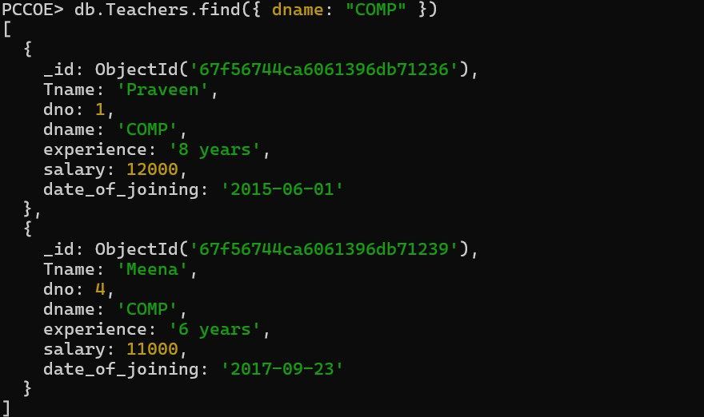
- Find the information about all teachers of computer,IT,and e&TC department
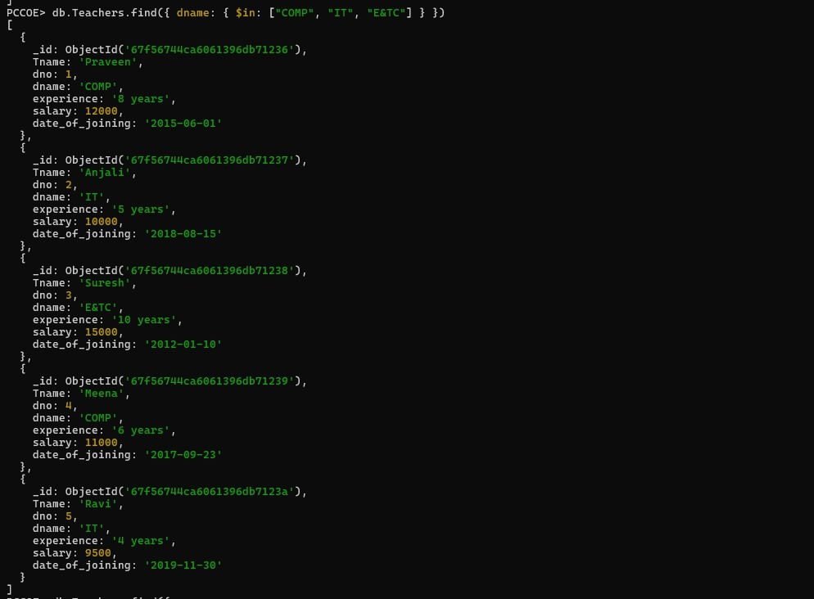

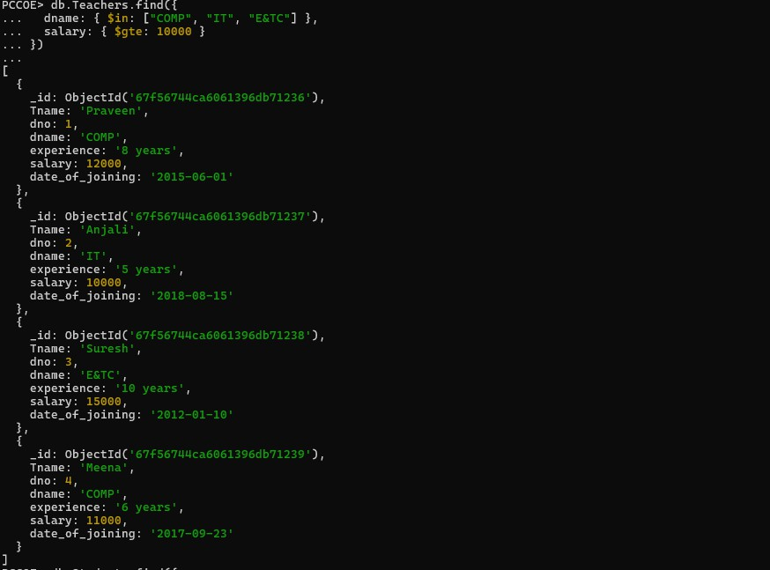
- Find the information about all teachers of computer,IT,and E&TC department having salary greateer than or equal to 10000/-
- Find the student information having roll_no = 2 or Sname=xyz
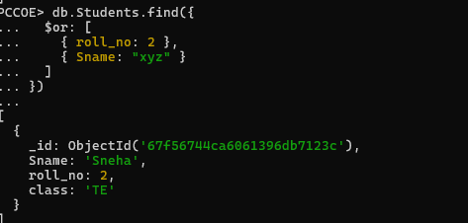

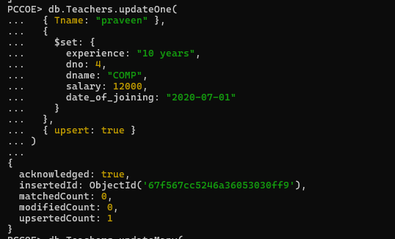
- Update the experience of teacher-praveen to 10years, if the entry is not available in database consider the entry as new entry.
- Update the deparment of all the teachers working in IT deprtment to COMP
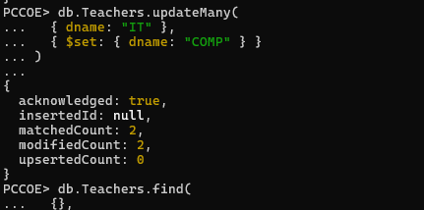

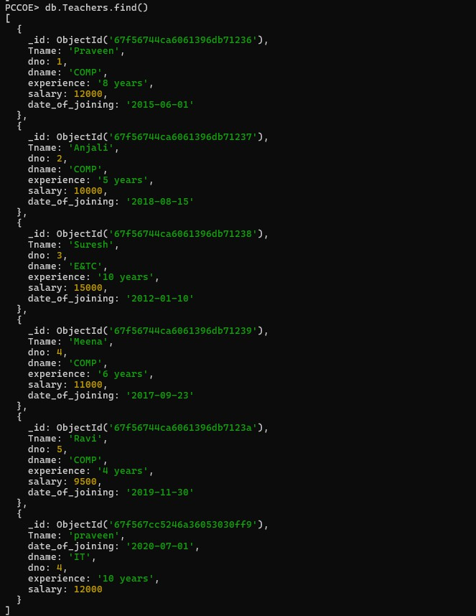

- find the teachers name and their experience from teachers collection
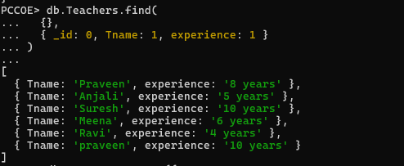
- Insert one entry in department collection
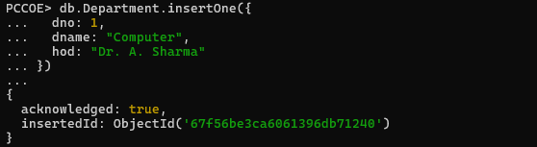
- Change the dept of teacher praveen to IT
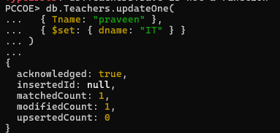

- Delete all the doccuments from teachers collection having IT dept.
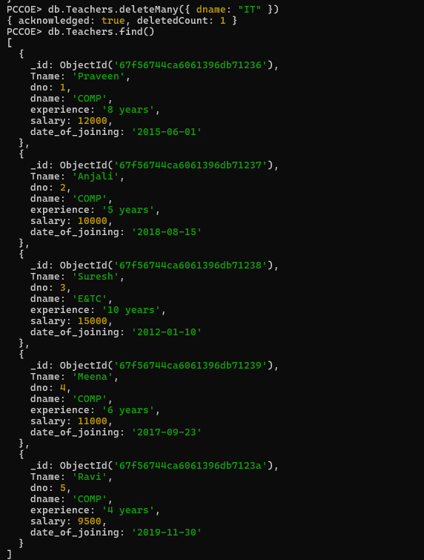

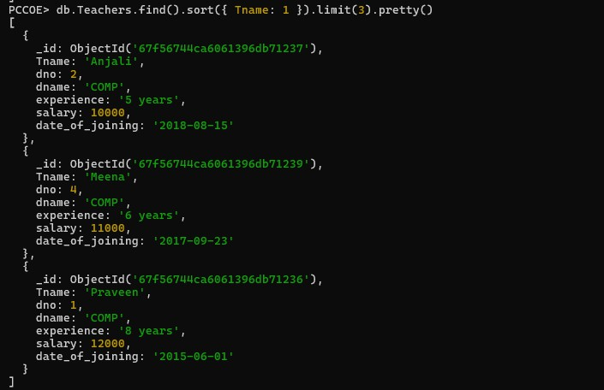
- display with pretty() method, the first 3 doccuments in teachers collection in ascending order

